Ideation Phase
Empathize & Discover

Date | 15-7-2026
Team ID | SWTID-2026-3345
Project Name | BookVerse – Online Book Store
Maximum Marks | 4 Marks

Empathy Map Canvas:
An empathy map is a simple, easy-to-digest visual that captures knowledge about a user's behaviours and attitudes. It is a useful tool to help teams better understand their users.
Creating an effective solution requires understanding the true problem and the person who is experiencing it. The exercise of creating the map helps participants consider things from the user's perspective along with his or her goals and challenges.
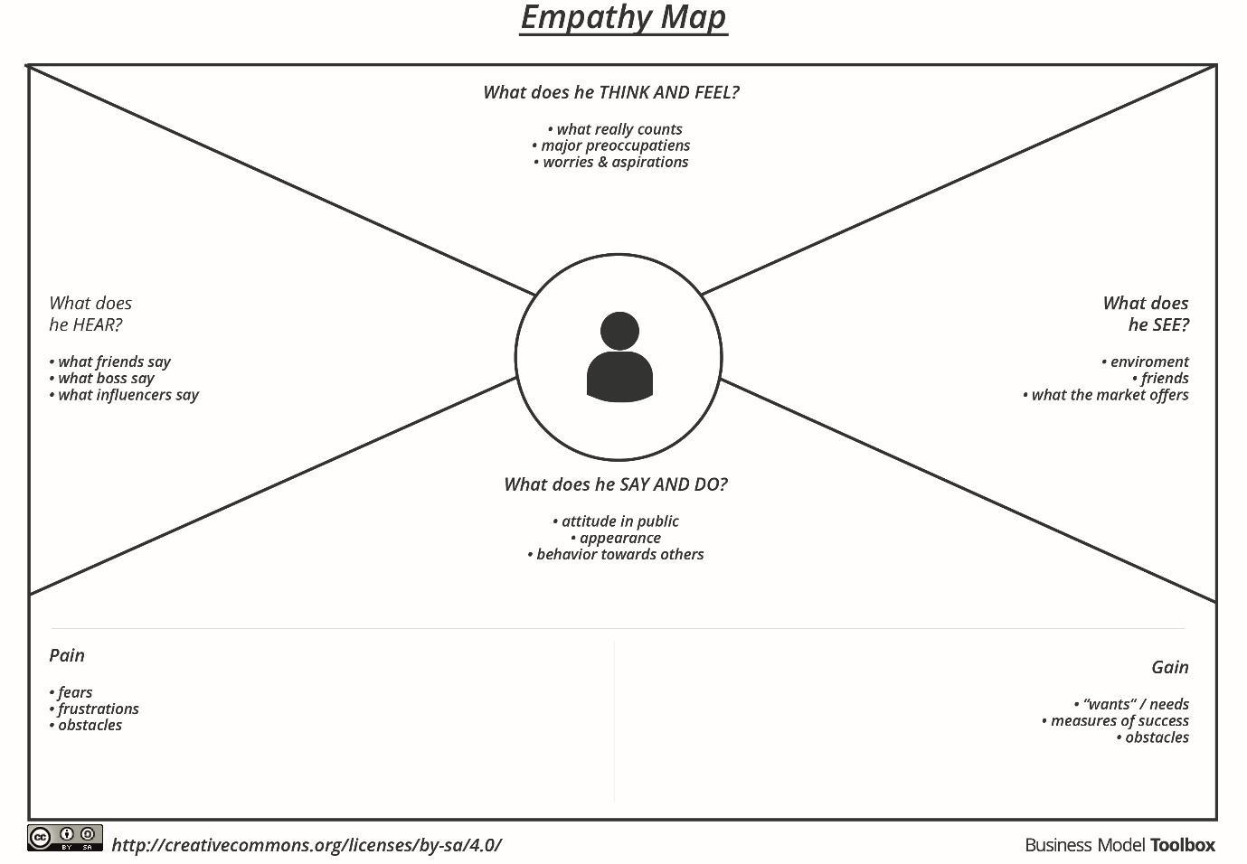
Figure 2.1: Empathy Map Canvas Empty Blueprint

Reference: https://www.mural.co/templates/empathy-map-canvas

Example: BookVerse – Online Book Store Application
Below is the completed Empathy Map Canvas modeling a book reader and seller on the BookVerse Online Book Store. It describes what they think, feel, see, hear, say, do, along with their pains and gains, ensuring our solution satisfies real-world user scenarios.
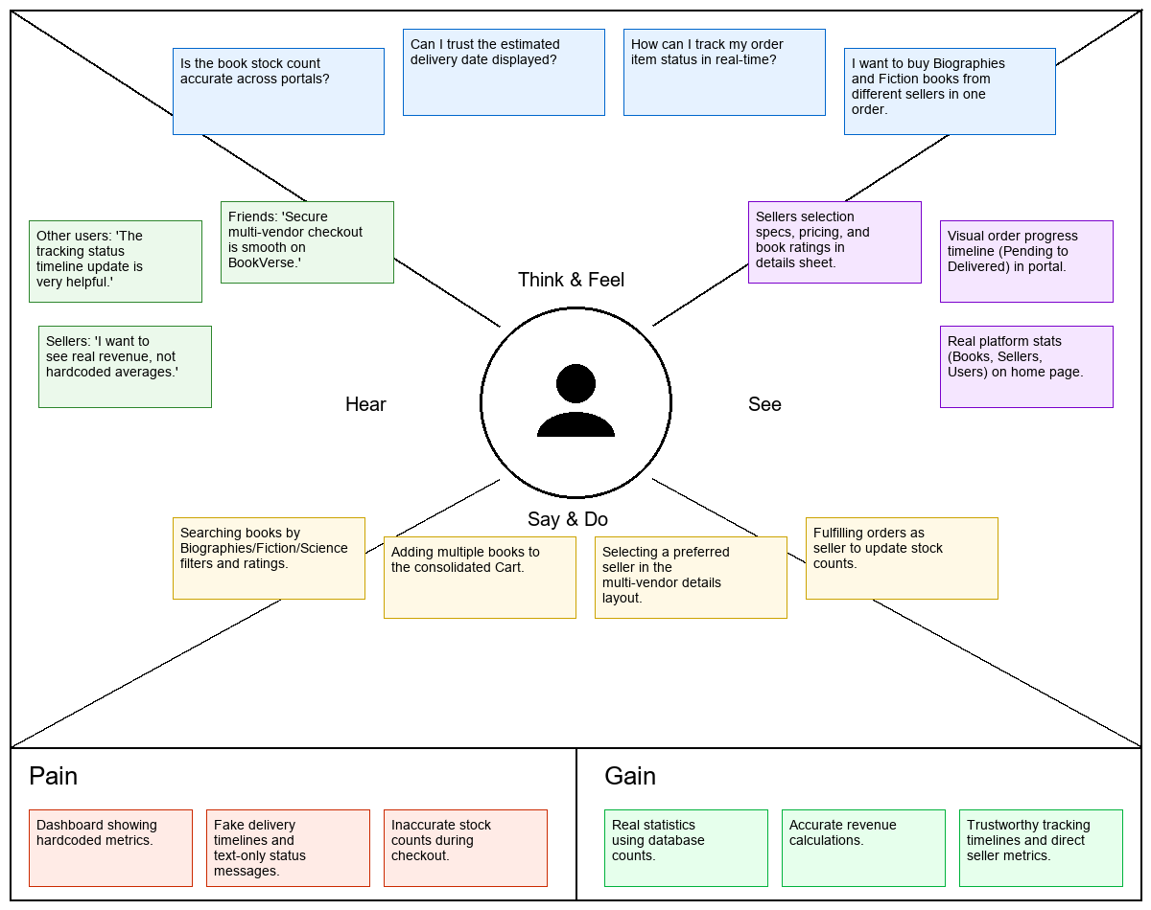
Figure 2.2: BookVerse Empathy Map Canvas (Completed)

